**Question 1**

General steps in step-size searching would be first we Obtain an 𝛼𝑖𝑛𝑖𝑡, then let 𝛼𝑗 = 𝛼𝑖𝑛𝑖𝑡 and initialize 𝑗 = 0. Then until 𝑓 (𝑥𝑘 + 𝛼𝑗𝑝𝑘) < 𝑓(𝑥𝑘), repeat set 𝛼𝑗+1 = 𝜌𝛼𝑗 , where 𝜌 is in (0, 1) and Increase 𝑗 by 1. Lastly Set 𝛼 = 𝛼𝑗.

**Question 2**

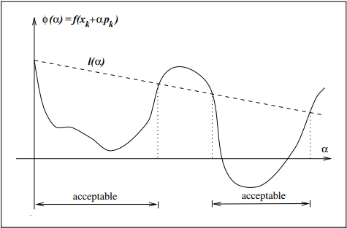

The sufficient decrease condition is illustrated in above figure. The right-hand-side of the algorithm *f*(xk) + c1α∇fkT *p*k, which is a linear function, can be denoted by *l*(α). The function *l*(·) has negative slope c1∇fKT *p*k, but because c1 ∈ (0, 1), it lies above the graph of φ for small positive values of α. The sufficient decrease condition states that α is acceptable only if φ(α) ≤ l(α). The intervals on which this condition is satisfied are shown in above figure which is shown acceptable.

**Question 3**

In exact line search, we just need to choose the steps length manually based on experience and let the algorithm run to find the local/global minimization. Typical line search algorithm will try out a sequence of candidate values for α stopping to accept one of these values when certain conditions are satisfied.

The inexact line search is done in two stages: A bracketing phase finds an interval containing desirable step lengths, and a bisection or interpolation phase computes a good step length within this interval. Some of the popular inexact line search condition are the Wolfie condition, Curvature condition, Armijo condition or Goldstein condition.

**Question 4**

The main purpose of having multiple conditions in step size searching will gave better step size and support different purpose of method. As example the Goldstein conditions are often used in Newton-type methods but are not well suited for quasi-Newton methods that maintain a positive definite Hessian approximation.

**Question 5**

Disagree, more condition also possible to have more candidate and it take more iteration to find its minimal point.